1.0: Project Overview
This project is a simple starter setup that demonstrates how to use Webpack 5 to bundle a basic front-end application and how to integrate Bootstrap 5 using npm. It includes support for bundling HTML, JS, and CSS files while automatically generating the destination folder during the build process.

2.0: Prerequisites
Before installing and running the project, ensure that the following tools are already installed on the device:
- Node.js (v24.x or later): Used to run JavaScript tools and manage dependencies.
- npm (v11.x or later): Installed automatically with Node.js and required for installing packages.
To verify the versions installed, run these commands in your terminal:
node -v
npm -v
If the versions appear, you are ready to proceed.
3.0: Installation
3.1: Create the project folder and initialise npm. The commands used are mkdir webpack, cd webpack, and npm init -y:
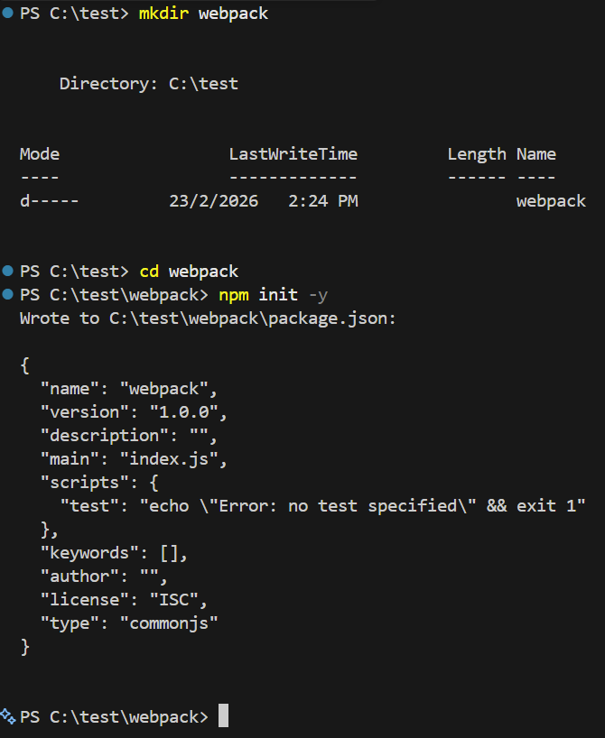
3.2: Install Webpack and essential tools to match “necessary dependencies” for bundling, CSS handling, and HTML generation. The commands used are npm install webpack webpack-cli --save-dev and npm install style-loader css-loader html-webpack-plugin --save-dev.
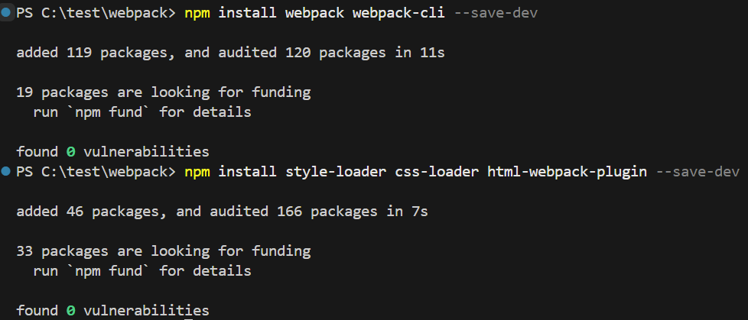
3.3: Create the source files.
Create a src/ folder with:
src/index.html:
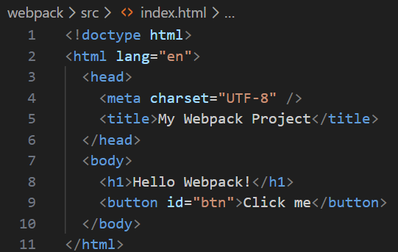
src/styles.css:
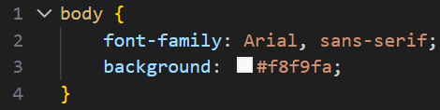

src/index.js:
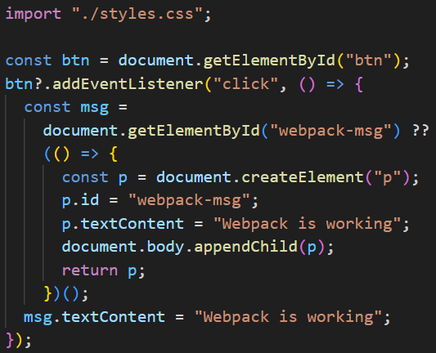
3.4: Add the Webpack configuration in the project root’s directory named webpack.config.js:
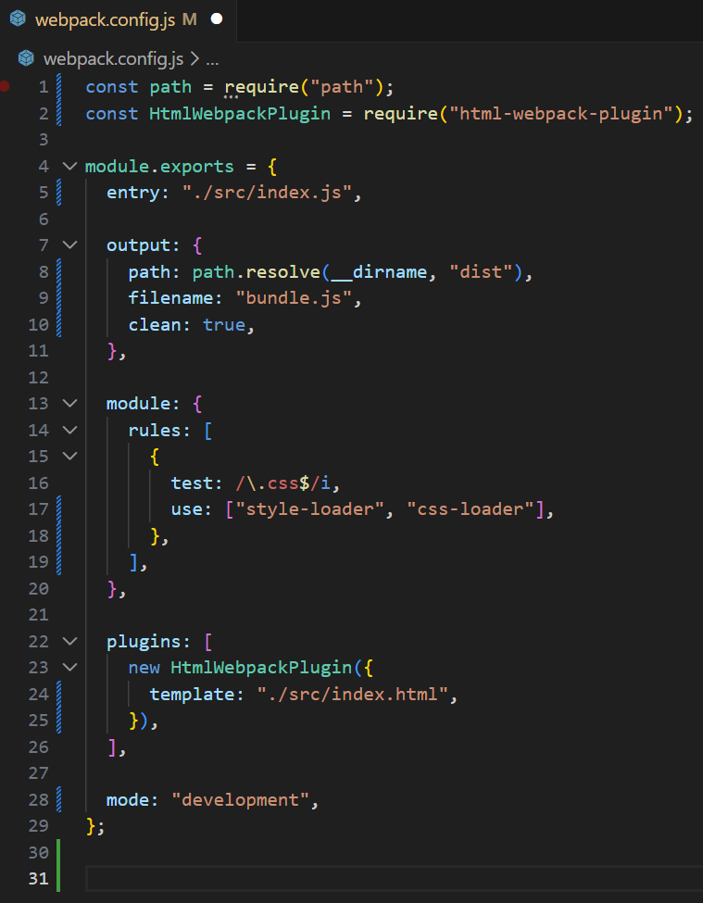
3.5: Add npm scripts in package.json:
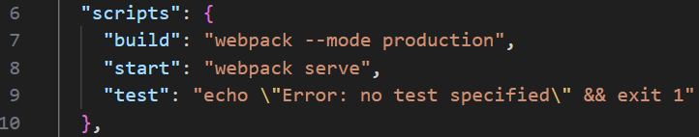
4.0: Webpack Configuration
- style-loader injects CSS into the Document Object Model (DOM), and css-loader allows importing CSS from JS.
- html-webpack-plugin creates a HTML file and auto-injects the bundled script.
- Entry/Output bundle the application into dist/bundle.js.
Commands
4.1: npm run build to build the project and create /dist:
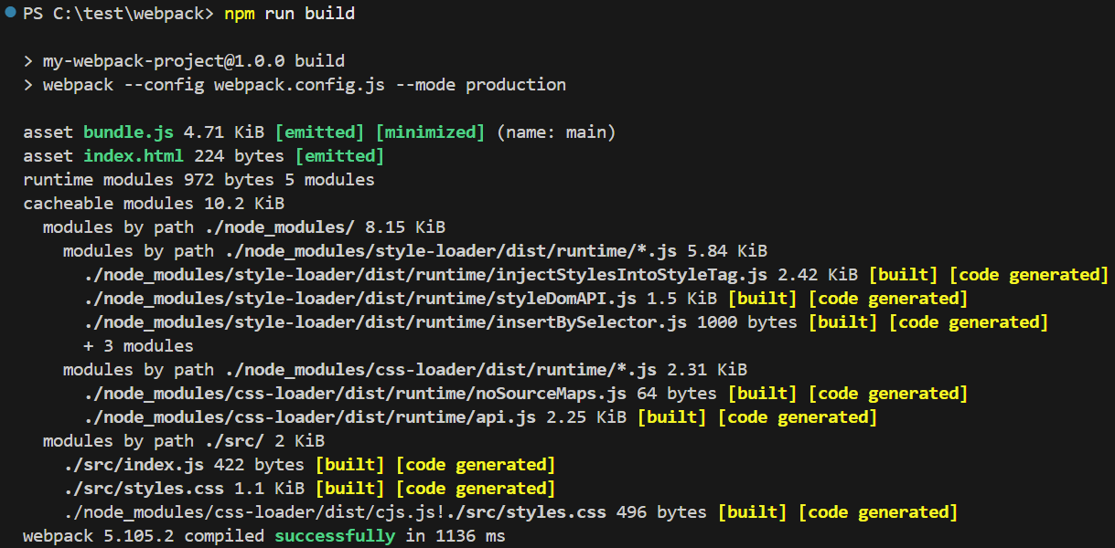
4.2: npm start produces the relevant links and information to open the Local Host.
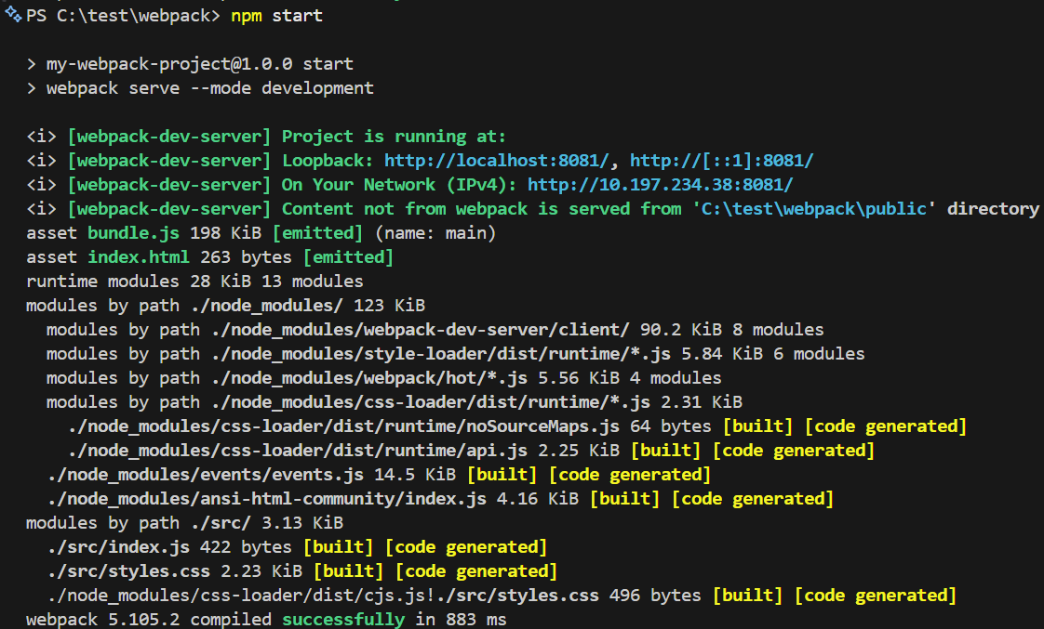
We can now see that the Local Host is running successfully:
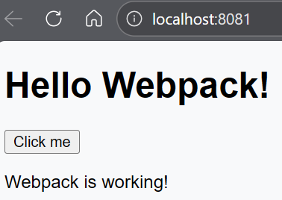
5.0: Bootstrap Integration
5.1: Install Bootstrap using the command npm install bootstrap.
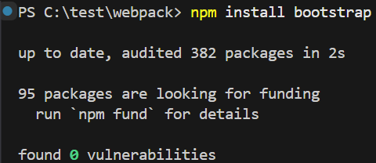
5.2: Import Bootstrap in the entry file with these lines of code in src/index.js:
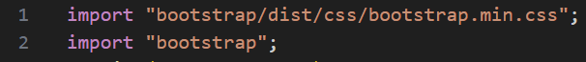
- The first import bundles Bootstrap’s precompiled CSS so you can use Bootstrap classes in the HTML file.
- The second import bundles Bootstrap’s JavaScript components (e.g., modals, dropdowns, tooltips). They work automatically because Bootstrap includes Popper internally since version 5.
5.3: Update index.html to use Bootstrap classes:
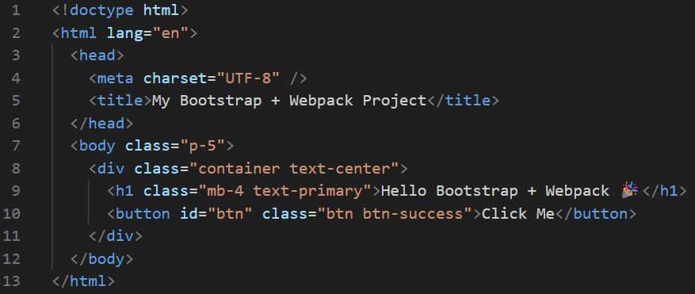
5.4: Rebuild the project using the command npm run build:
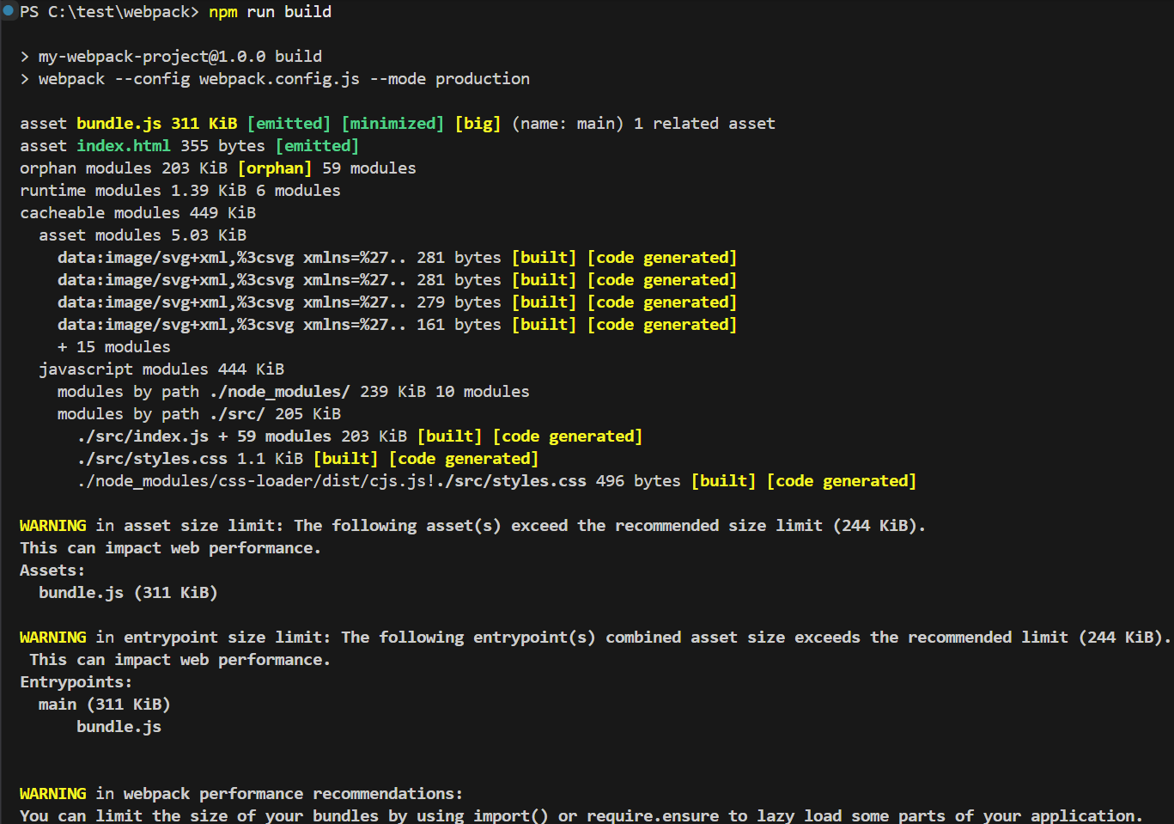
5.5: Rerun the project using npm start to obtain the relevant links and information to open the Local Host:
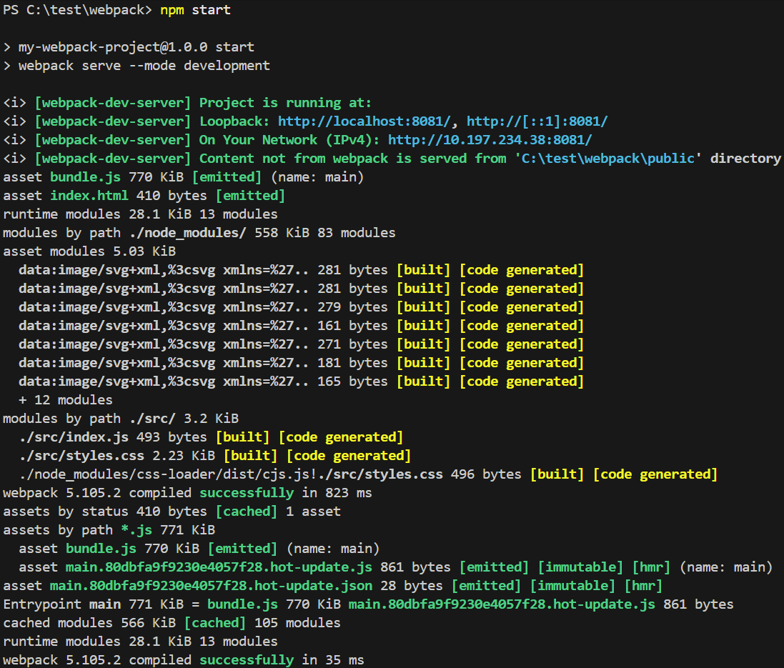
We can now see that the Local Host is running successfully:
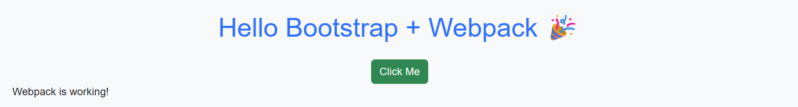
6.0: Folder Structure
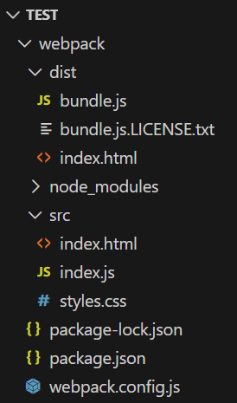
6.1: What Each Folder and File Represents
dist/
It is an output folder when npm run build. It contains:
- bundle.js: A Webpack-bundled JavaScript.
- bundle.js.LICENSE.txt: Autogenerated license information.
- index.html: Generated by html-webpack-plugin.
node_modules/
It is automatically created by npm, and contains all installed packages such as:
- Webpack
- style-loader
- css-loader
- html-webpack-plugin
- Bootstrap
The folder should never be edited manually. It is regenerated entirely when npm install
src/
The actual application source code:
- index.html: Starting HTML template.
- index.js: Entry point for Webpack (imports the CSS and Bootstrap; handles button logic).
- styles.css: Custom styles.
package.json and package-lock.json
Dependency configuration:
- package.json: Metadata, installed packages, and npm scripts.
- package-lock.json: Locks exact dependency versions.
webpack.config.js
The Webpack configuration, including:
- Entry point
- Output settings
- Loaders for CSS
- HTML plugin configuration
7.0: Running the Project
After completing the installation, Webpack setup, and Bootstrap integration, the project can be run in two modes, development and production.
7.1: Start the Development Server
Use Webpack Dev Server to run the project locally with live reloading:
npm start
This serves your bundled files and automatically reloads the page whenever you update your source code.
The project will be available at: http://localhost:8081/
7.2: Build for Production
To generate an optimised, production-ready bundle inside the dist/ folder, run:
npm run build
This command:
- Bundles HTML, CSS, and JavaScript.
- Minimises and optimises the output.
- Produces a clean dist/ folder with only the necessary files.
8.0: Troubleshooting
These are some of the common issues we have encountered and the solutions to resolve them.
8.1: “Module parse failed: import/export may appear only with sourceType: module”
Cause: The project is using CommonJS (require) instead of ES modules (import) in Webpack.
Solution: Use require (“./styles.css”) for CSS imports or convert the whole project to ESM.
8.2: Dev Server Not Starting
Cause: If the error message npm ERR! Missing script: "dev" appears, this means that the script does not exist in package.json.
Solution: Use npm start, as the project uses "start": "webpack serve --mode development".
8.3: “Module Not Found” Errors
Verify that the paths are correct and case-sensitive:
Correct: src/styles.css
Incorrect: src/Styles.css
Also, ensure that all files exist exactly as referenced.

